Q2. Explain steps for JDBC connection

* Steps for JDBC connection are:
  + Import JDBC Driver
    - Import statements tell the Java compiler where to find the classes to refer in the code
    - To use the standard JDBC driver we import it as
      * Import java.sql.\*;
  + Register JDBC Driver
    - We must register the driver in our program before using it
    - Registering the driver can be done by two approaches
      * Approach 1
        + Class.forName(“com.mysql.cj.jdbc.Driver”)
      * Approach 2
        + Driver myDriver = new oracle.jdbc.driver.OracleDriver();
        + DriverManager.registerDriver( myDriver );
  + Database URL formalation
  + 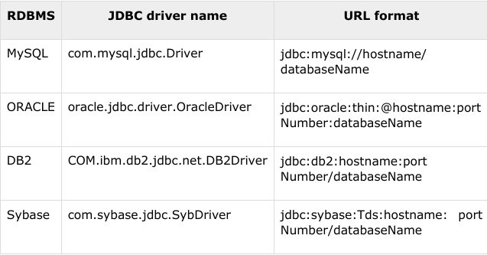
  + Create Connection object
    - Connection object is created in the format
      * Database url
      * Username
      * Password
    - Connection con = DriverManager.getConnection(URL, USER, PASS)

Q2.

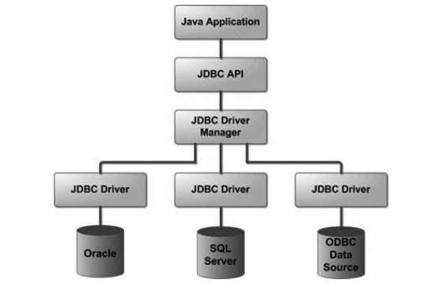

Q5. Explain different types of JDBC drivers

* There are 4 types of JDBC drivers
  + JDBC-ODBC bridge driver
    - This is integrated in Java.
    - Suitable to run with a local database.
    - Needs the client to install database software.
    - Performance is slow
  + Native API driver
    - Needs configuration before installing native code on client side
    - Dependent of DBMS.
    - Client can connect directly to database server
    - Provides adequate speed to access database.
  + Network Protocol Driver
    - This is the most flexible configuration
    - Needs an intermediate server to function which has to be configured by the vendor
    - Can access multiple databases from one driver
    - Independent of DBMS
  + Thin Driver
    - This is the fastest way to communicate SQL queries to the DBMS
    - This allows direct call to database without client pre-configuration
    - A different driver needs to be loaded foreach DBMS
    - Not appropriate for Applets

Q6. Diferrence between type 1 and type 2

* Though both type 1 and type 2 drivers are not written in Java, there was some significant difference between them. Type 2 driver has better performance than type 1 driver because of less layer of communication and translation. As opposed to the type 1 JDBC driver, in which JDBC calls are translated into ODBC calls before they go to the database, type 2 JDBC driver directly connects to DB client using the native library.

Q7. Difference between type 3 and type 4

* The main difference between type 3 and type 4 JDBC drivers was the removal of 3 tier architecture. Type 4 JDBC drivers directly connect to the database using their native protocol as opposed to the network protocol used by type 3 drivers. Though both type 3 and type 4 driver is written in Java.
* Another key difference is the ease of use, type 4 drivers just require one JAR file into classpath in order to connect to DB. The performance of the Type 4 JDBC driver is also better than the type 3 driver because of direct connectivity to the database as opposed to 3 tier architecture of the type 3 driver.